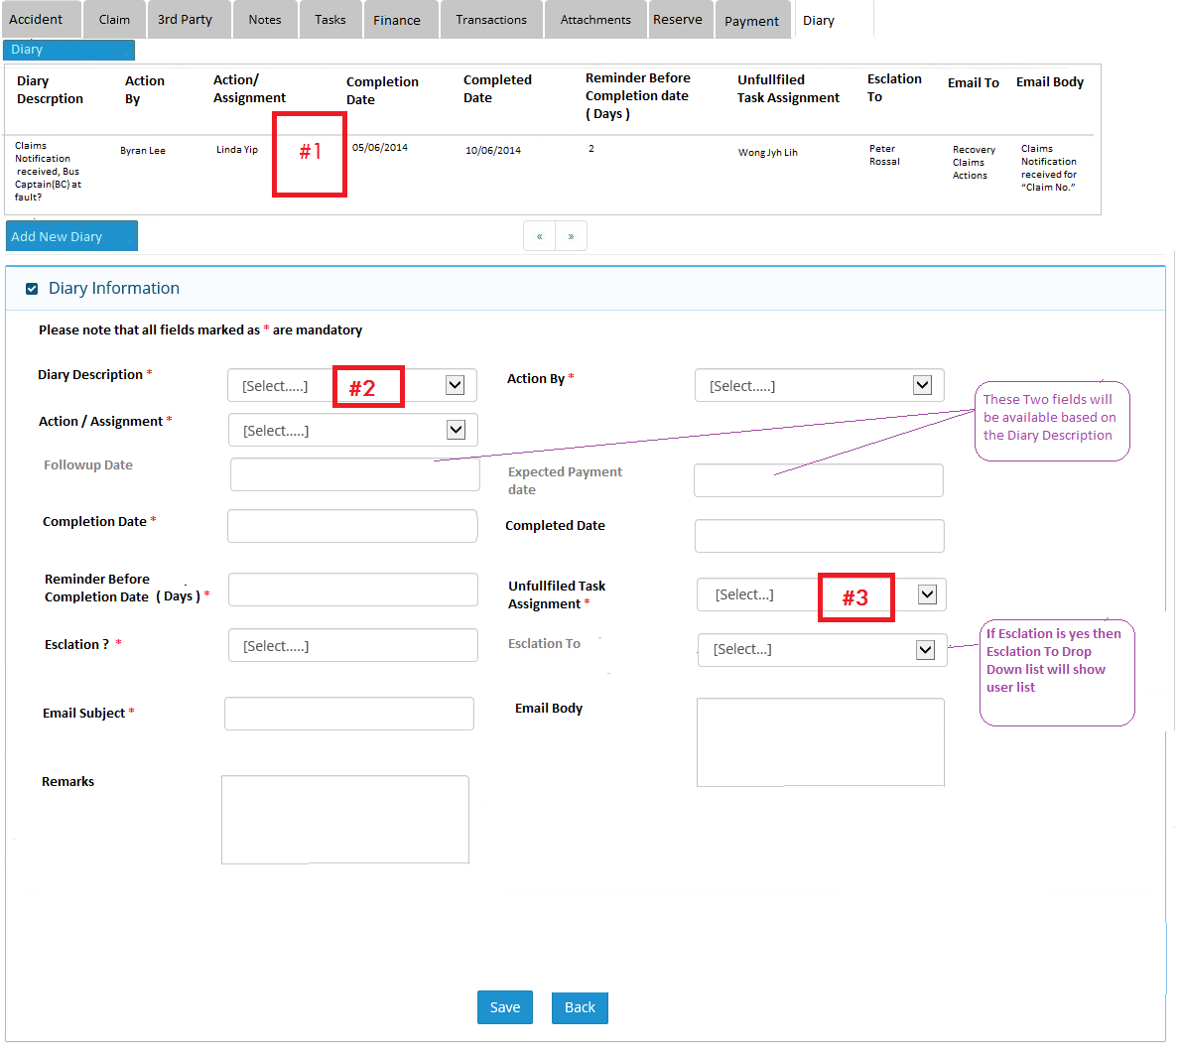

Points:

#1 – All outstanding tasks will be displayed here or should there be a filter to display all diary tasks – completed and outstanding

#2 – Will it be all the tasks as highlighted in the documents and is there any duplicate tasks validation?

#3 - Can this re-assignment be on block basis (user able to select multiple users) to handle staff on leave cases?